

**Lab 6 - Apache Spark**

**Student: Ricardo Tassio | Student Id:** C0932497 **Email**: C0932497@mylambton.ca

**Date:** August 11 2024

**Repository:** https://github.com/ricardotassio/apache_spark_merge_csv

**CODE:**

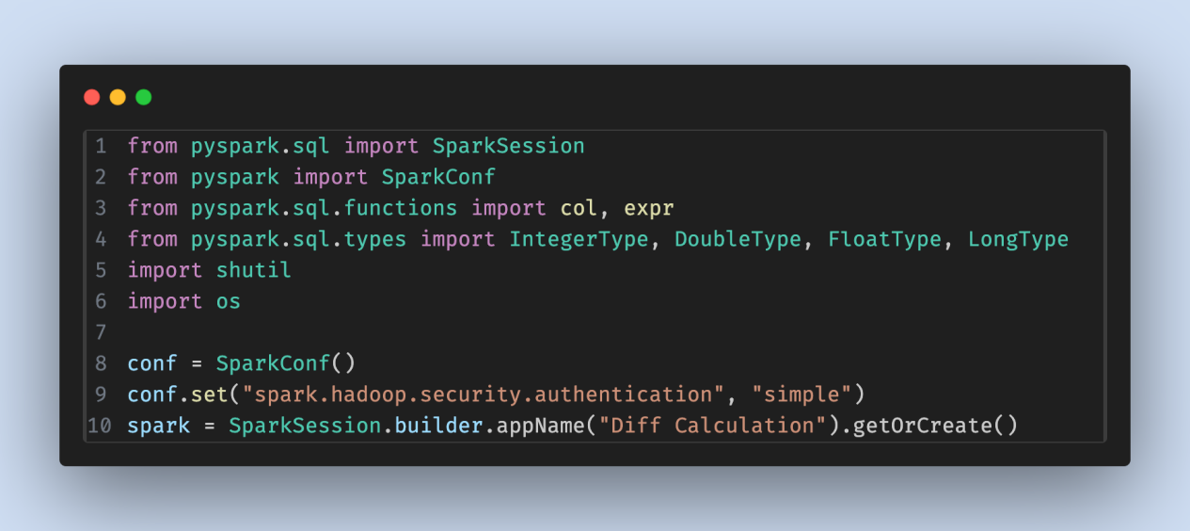

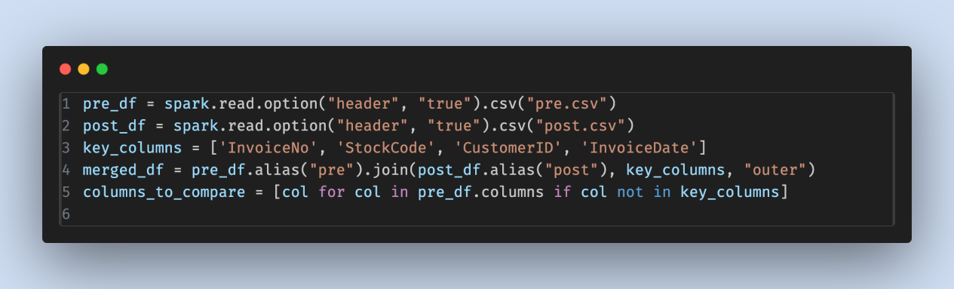

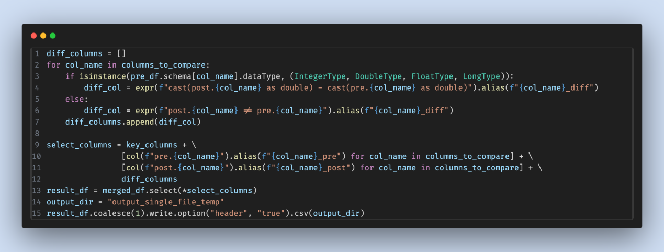

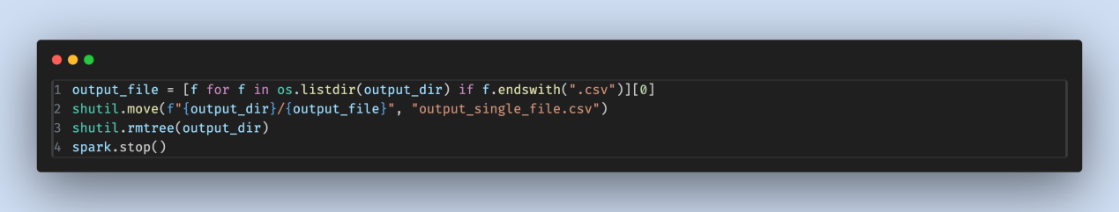

**OUTPUT:**

